Student attendance Marks Text Messaging Alert Systems for Colleges & Schools

Abstracts

Our messaging system empowers colleges, universities, and other educational institutions to instantly communicate with an entire campus in a matter of seconds. With our (SMS) text messaging software you can send out campus-wide text alerts, which will be delivered to your Faculty’s and student’s phones immediately.
Invite Faculty’s and student’s to join the service to receive emergency alerts, event reminders, meeting reminders and much more.

Introduction

SMS Text Messaging Alert Systems, the new generation Business Messaging System, is the ultimate in SMS revolution that sends out individualized, Bulk text/Flash messages directly from your PC to the recipient without internet Connectivity.
SMS Text Messaging Alert Systems is an application that can be installed in a laptop, desk top or a server with a GSM device connected to it to act as a SMS server linked to the service provider. For sending messages in bulk, with specified task and with numerous features. Else in mobile phone this won’t be possible to send it fast.

SMS Text Messaging Alert Systems Features
- Managing Contacts.
- Managing Groups.
- Sending Messaging to desired numbers.
- Sending message to desired contacts and numbers.
- Send message to group.
- Internet is NOT required
- User Friendly Software
- Cost effective
System Analysis
Existing System
- A separate person for intimating students and staff’s regarding notice has to be kept.
- Event and Placement notifications and timings may not be received by students n staff if they are absent.
- In the college community, every year, thousands of students miss examination due to sudden change of examination time table. Most of the time, the information is placed on the notice board and not all students can access it.
Proposed System
- Colleges and universities can utilize the information power of our alert system to improve their communication with students and the staff.
- The manual process like making phone call, sending post’s which more costly compare to SMS system are can be avoided.
- Now a day every one has cell phones, it’s easy to notify regarding events and other activities using SMS system.
System Design

Use case diagram
Student Registration

Attendance and Marks Updates

Sending SMS
Notice

Architectural Design

DFD
Student Registration

Notice

Sending SMS

Attendance & Marks Updates

USER

Database

Software Requirement Specification

User Interface
* Swing - Swing is a set of classes that provides more powerful and flexible components that are possible with AWT. In addition to the familiar components, such as button checkboxes and labels, swing supplies several exciting additions, including tabbed panes, scroll panes, trees and tables.
* Applet - Applet is a dynamic and interactive program that can run inside a web page displayed by a java capable browser such as hot java or Netscape.

Modules

Student Register

Marks and Attendance Update

Sending SMS

Notice

Student Register: Students can get register in this module by use a unique ID provided by College.

Marks and Attendance Update: Students marks and attendance can be updated in the database by using ID provided by the colleges.

Sending SMS: SMS’s are sent to the students depending on the category. SMS’s are of type Attendance or Marks.

Notice: In this module messages can be sent to the faculty.

System Requirements:

Hardware:

PROCESSOR : PENTIUM IV 2.6 GHz
RAM : 512 MB DD RAM
MONITOR : 15” COLOR
HARD DISK : 20 GB
CDDRIVE : LG 52X
KEYBOARD : STANDARD 102 KEYS
USB Port GSM Modem
Any GSM SIM card

Software:

FRONT END : Java(Swings)
OPERATING SYSTEM : Window’s Xp
BACK END : MS Access

Literature Survey

GSM
GSM (Global System for Mobile Communications: originally from Groupe Spécial Mobile) is the most popular standard for mobile telephony systems in the world. The GSM Association, its promoting industry trade organization of mobile phone carriers and manufacturers, estimates that 80% of the global mobile market uses the standard. GSM is used by over 1.5 billion people across more than 212 countries and territories. Its ubiquity enables international roaming arrangements between mobile network operators, providing subscribers the use of their phones in many parts of the world. GSM differs from its predecessor technologies in that both signaling and speech channels are digital, and thus GSM is considered a second generation (2G) mobile phone system. This also facilitates the wide-spread implementation of data communication applications into the system.
The ubiquity of implementation of the GSM (Global System Market) standard has been an advantage to both consumers, who may benefit from the ability to roam and switch carriers without replacing phones, and also to network operators, who can choose equipment from many GSM equipment vendors.[4] GSM also pioneered low-cost implementation of the short message service (SMS), also called text messaging, which has since been supported on other mobile phone standards as well. The standard includes a worldwide emergency telephone number feature (112).
Newer versions of the standard were backward-compatible with the original GSM system. For example, Release '97 of the standard added packet data capabilities by means of General Packet Radio Service (GPRS). Release '99 introduced higher speed data transmission using Enhanced Data Rates for GSM Evolution (EDGE).

Technical details
GSM is a cellular network, which means that mobile phones connect to it by searching for cells in the immediate vicinity. There are five different cell sizes in a GSM network—macro, micro, pico, femto and umbrella cells. The coverage area of each cell varies according to the implementation environment. Macro cells can be regarded as cells where the base station antenna is installed on a mast or a building above average roof top level. Micro cells are cells whose antenna height is under average roof top level; they are typically used in urban areas. Picocells are small cells whose coverage diameter is a few dozen metres; they are mainly used indoors. Femtocells are cells designed for use in residential or small business environments and connect to the service provider’s network via a broadband internet connection. Umbrella cells are used to cover shadowed regions of smaller cells and fill in gaps in coverage between those cells.
Cell horizontal radius varies depending on antenna height, antenna gain and propagation conditions from a couple of hundred meters to several tens of kilometres. The longest distance the GSM specification supports in practical use is 35 kilometres (22 mi). There are also several implementations of the concept of an extended cell, where the cell radius could be double or even more, depending on the antenna system, the type of terrain and the timing advance.
Indoor coverage is also supported by GSM and may be achieved by using an indoor picocell base station, or an indoor repeater with distributed indoor antennas fed through power splitters, to deliver the radio signals from an antenna outdoors to the separate indoor distributed antenna system. These are typically deployed when a lot of call capacity is needed indoors; for example, in shopping centers or airports. However, this is not a prerequisite, since indoor coverage is also provided by in-building penetration of the radio signals from any nearby cell.
The modulation used in GSM is Gaussian minimum-shift keying (GMSK), a kind of continuous-phase frequency shift keying. In GMSK, the signal to be modulated onto the carrier is first smoothed with a Gaussian low-pass filter prior to being fed to a frequency modulator, which greatly reduces the interference to neighboring channels (adjacent-channel interference).

JAVA Introduction

Java is a high-level, third generation programming language, like C, FORTRAN, Smalltalk, Perl, and many others. You can use Java to write computer applications that crunch numbers, process words, play games, store data or do any of the thousands of other things computer software can do.

Key Differences between C++ and Java:

No pointers Just references
Java has references but there are no pointers. This basically means there is no way for you to directly access the memory that has been reserved for an object except through the use of the object or primitive itself. It is possible to have multiple objects of the same type referencing the same memory. In C++ it is possible to have multiple object and primitive pointers pointing at the same block of memory and for each to operate on it in a different way.

Java is Object-Oriented
In C++ you can have functions that are not attached to classes. The main function in C++ is explicitly not attached to a class. In Java, all function, including the main function, are attached to classes that means within class. Everything is an object here.
Java is a Platform-Independent
When Java program is compiled; it produces a special format called byte code and not executable code. Java bytecode is executed by Java run-time system, which is called Java Virtual Machine. In its standard form, JVM is an interpreter for bytecode. Java bytecode is exactly the same on every platform. Only JVM needs to be implemented on every machine. Thus details of JVM differ from platform to platform. The interpreter reads the byte code and translates it into the native language of the host machine on the fly. Since the byte code is completely platform independent, only the interpreter and a few native libraries need to be ported to get Java to run on a new computer or operating system. Thus due to JVM, Java becomes architecture neutral.

Java is safe and simple
Java was designed from the ground up to allow for secure execution of code across a network, even when the source of that code was not trusted and possibly malicious. Furthermore Java has strong typing. Variables must be declared, and variables do not change types when you aren't looking. Casts are strictly limited to casts between types when you are not loosing data. Thus you can cast an int to a long but not an int to a String. Java implements a robust exception handling mechanism to deal with both expected and unexpected errors. The worst that an applet can do to a host system is bringing down the runtime environment. It cannot bring down the entire system.
Most importantly Java applets can be executed in an environment that prohibits them from introducing viruses, deleting or modifying files, or otherwise destroying data and crashing the host computer. A Java enabled web browser checks the byte codes of an applet to verify that it doesn't do anything nasty before it will run the applet. The biggest security issue in computing today is bugs. Java, by making it easier to write bug-free code, substantially improves the security of all kinds of programs.

Java is Multithreaded
Java is inherently multi-threaded. A single Java program can have many different threads executing independently and continuously. Three Java applets on the same page can run together with each getting equal time from the CPU with very little extra effort on the part of the programmer.

Java has Garbage Collector
One of the most difficult tasks in C++ is keeping track of objects and then deleting those to free up memory and prevent data leaks. In Java there is no delete command because Java does memory garbage collection for free when objects are no longer referenced. There is a slight performance decrease associated with this service, but it greatly aides in providing reliable crash free programs. There are constructors and these do allocate memory on the heap, but this is transparent to the programmer.

Use of try and catch mandatory
For the most severe and common errors in Java the use of catch and try is mandatory. It is built into Java’s grammar that these error checking precautions must be present or else your program will not compile. In C++, catch and try are also available, but are not mandatory.

A First Simple Program
Let’s start by compiling and running the short sample program.
/* This is a simple Java program*/
class HelloWorld {
public static void main (String args[]) {
System.out.println("Hello World!");
}
}
To write the code you need a text editor. You can use any text editor like Notepad, Brief, emacs or vi. You should not use a word processor like Microsoft Word or WordPerfect since these save their files in a proprietary format and not in pure ASCII text. If you absolutely must use one of these, be sure to tell it to save your files as pure text. Generally this will require using Save As... rather than Save. By convention, the name of source file should be same as name of the class which contains main. Java is case sensitive.

Compiling the program
To compile the program, execute the compiler, javac, specifying the name of the source file on the command line, as shown here:
C:\>javac HelloWorld.java
The javac compiler creates a file called HelloWorld.class that contains the bytecode version of the program.
To run the program, you must run the Java Interpreter, called java and pass the class name HelloWorld, as shown here:
C:\>java HelloWorld
When the program is run, following output is displayed: Hello World!
When java source code is compiled, each individual .class file is produced for each class which contains its bytecode. So when you write java HelloWorld, you are specifying the class file which interpreter needs to look for and execute the code.

Then there is simple class keyword which can be preceded by abstract, final or public.

• abstract class contains methods some of which are implemented and some are empty ( e.g. sort() { })
• final class describes that a class have no subclasses.
• public class can be used and instantiated by all classes in the same package.

main is a method in Java. Using some of the modifiers as shown below, scope of a method can be restricted:
• public: anyone can call public method
• protected: only methods in the same package or of subclasses can call protected method.
• private: only methods of the same class (not methods of subclass) can call a private method.
• If none of above is used then the method can be called by objects of classes in the same package.
Some additional modifiers:
• Abstract: a method declared as abstract will have no code and appears only in abstract class. e.g. public abstract void setElement (int i);
• final: final method can not be overridden by a subclass.
• static: static method is associated with a class itself and not with a particular instance of class.
So our main is associated with HelloWorld class only and it won’t be associated with any of its instance.
e. g. HelloWorld hw; //create object
hw.main (); is not allowed.
Constructor method has same name as class. It has no return value. An abstract, static or final constructor is not allowed.
The argument passed as a parameter args to the main method are command line arguments. It’s an array of Strings starting at args[0]. All parameters in Java are passed by value that means a copy of variables is created and passed.
Java provides a built-in static object, called System.out that performs output to the standard output device. println prints the string followed by newline character. System.out is an instance of java.io.PrintStream class.

Data types and variables
Java is strongly typed language. Every variable has a type, every expression has a type and every type is strictly defined.

Java defines 8 simple types of data: byte, short, int, long, float, double, char, boolean.
Java variable is similar to C++ variable. It is defined by the combination of
an identifier, a type and an optional initializer.
Strings are enclosed in double quotes. e.g. “Hello”

Expressions
Expressions make use of literals explained above, variables and operators. The Assignment Operator, the Dot Operator, Arithmetic Operator, Bitwise Operator, Increment/Decrement Operator and Logical Operator are similar to one in C++. Creating a new object involves the use of new operator. Although, signature of method does not include the return type, Java does not allow two methods with same signature to return different types.
Unlike C++, Java does not allow operator overloading.

String Concatenation
Strings can be composed using the concatenation operator (+).
e.g. String str1= “hello”;
String str2= “there”;
String str3=str1+str2;
would result into hellothere.
This shows how Java converts nonstring constants into strings, when they
are involved in a string concatenation operation.

Operator Precedence
postfix operators expr++ expr--
unary operators ++expr --expr +expr -expr ~ !
multiplicative * / %
additive + -
shift << >> >>>
relational < > <= >= instanceof
equality == !=
bitwise AND &
bitwise exclusive OR ^
bitwise inclusive OR |
logical AND &&
logical OR ||
conditional ? :
assignment = += -= *= /= %= &= ^= |= <<= >>= >>>=

Inheritance and Polymorphism
Inheritance is one of the cornerstones of Java. A class that is inherited is called superclass and one that does inheriting is called subclass. Subclass inherits all the variables and methods defined by superclass and add its own unique elements. However, subclass can not directly access the members of superclass which are declared as private. Java’s solution to this problem is the use of keyword super.
A subclass can call a constructor method in superclass by the use of super as
follows: super (parameter-list);

Super must always be first statement executed inside subclass’s constructor.
e.g. class A extends B {
int k;
A (int x, int y, int z, int w) {
super (x, y, z); //call superclass constructor
k=m;
}
}
Here we have subclass A which inherits superclass B. Notice the use of java keyword extends which signifies the inheritance. In the constructor of class A, constructor of superclass is called. Remember that x, y, and z are private in superclass.
Second form of super acts somewhat like this, except it always refers to the superclass of subclass. e.g.
class A { int k; } class B extends A {
int k;
B(int m, int n) {
super.k = m; //k in A
k = n; //k in B
}
}
super always refers to the superclass immediately above the calling class.

Abstract Class
Remember abstract class we talked above. Abstract class can be inherited by another subclass. but it needs to implement all the methods in that interface because some of the methods might not be implemented. This is the reason that an abstract class can not be instantiated using new operator.

Packages and Interfaces
The java language takes a general and useful approach to the organization of classes into programs. Every public class is defined in separate file with extension .java. A set of all relevant classes, all defined in a common subdirectory called a Package. Every file in a package starts with the line:
package <package-name>;

Using Other Packages
In java, we can use classes that are defined in other packages using dot operator. e.g. public boolean Temperature (TA.Measures.Thermometer thermometer, int temp);. Here TA is package, Measures is subpackage and Thermometer is class of this package. As you can see, as we come to low level in hierarchy, we become specific.

The import command
We can use import command similar to include command.
import <Package-name>.<class-name>; We can import whole package as follows: import <package-name>.*;

Thus in any file hierarchy of these declaration would be e.g.
package student;
import TA.Measures;
class MeasureTemp {
public boolean Temperature (TA.Measures.Thermometer thermometer, int
temp) { ….} }
Interfaces
Interface is just declaring prototype. e.g. consider we want implement stack
of interger objects.
public interface Stack {
public int size();
public boolean isempty();
public int top();
public void push();
public int pop();
{
Save this file as Stack.java
Interfaces must be public. Now a class can implement this interface the way
it wants. But that class must implement all the methods declared in the
interface. So general form will be:
class A implements Stack {…..}
or it can be class A extends B implements Stack {….}
However, one interface can extend as many interfaces it wants. This is how multiple inheritance is achieved. e.g.
Public interface X extends Y, Z {….}
Here Y and Z are interfaces which are inherited by X. Now class W can implement X so that it obtains methods of X, Y as well as Z.

Exception Handling
An exception is abnormal condition which occurs in code at run time. There are errors about which we can not do except returning gracefully displaying error message. But we can handle exception manually.
All exception types are subclass of the built in class Throwable. Exception is subclass of Throwable. This class is used for exception conditions that user programs should catch. Then subclass of Exception is RuntimeException.
Exceptions of this type are automatically defined for the programs that we write and include things such as divide by zero and invalid array indexing.

Throwing exception
Exceptions can be generated by java run time system or can be manually generated. Java exception is an object which is thrown in the method caused an error. That method catches the exception or passes it on and exception is handled. e.g. if we try to delete 10
element from array of 5
elements, the code may throw a BoundryViolationException as follows:
If (insertIndex () > size ()) {
throw new
BoundryViolationException (“no element at this index”);
The throws clause
When a method is declared, it is appropriate to specify the exception it might throw. It let Java compiler know which exception to prepare for. e.g.
public void insertIndex () throws BoundryViolationException {…..}
Thus this exception can be handled somewhere else and not necessarily catch in this methods only.
e.g. public class BoundryViolationException extends RuntimeException {
public BoundryViolationException (String e) {
super (e);
}
}
Here this exception is handled by RuntimeException class.

Catching Exception
If an exception is to be handled in the method itself then we put the code of method in try block and have control flow to jump to a predefined catchblock. After catch block, if finally block is not defined then control goes to first statement after last line of the entire try-catch block. e.g.
int index = Integer.MAX_VALUE;
try {
String s = max[index];
}
catch (BoundryViolationException bve) {
System.out.println (“the index” + index +” is outside of the array”);
}
If this code does not catch a thrown exception, the flow of control will exit and go to the method that called this method. If it’s not catching this exception then it will jump to part which called this code and so on. Eventually, if no code catches exception, Java runtime exception catches exception.
Swings

Easier Life through Swing: JFileChooser
The idea behind this program is to show how a simple event can be processed using Swing, as well as showing how Swing’s built in graphical interfaces make your life much easier.

The toplevel components provided by Swing are:
1. JApplet - for applets within web pages
2. JDialog - for dialog boxes
3. JFrame - for building applications

All other Swing components derive from the JComponent class. JComponent provides

Tool tips - little windows with explanations
Pluggable look and feel - as described
Layout management - items within the component
Keyboard action management - Hot keys and so on.

And other facilities
Swing implements an MVC architecture.

Screen Shots

Login page

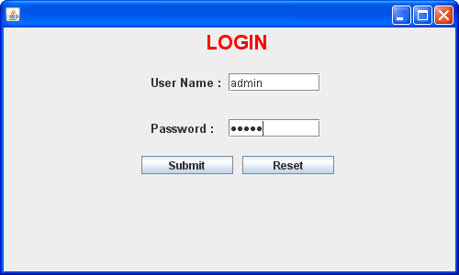

Registration Page

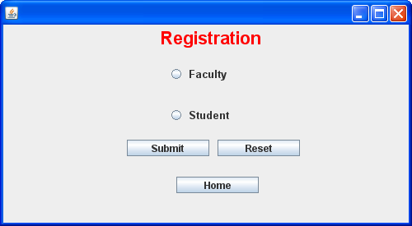

Faculty Registration

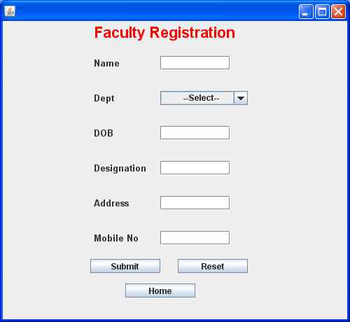

Student Registration

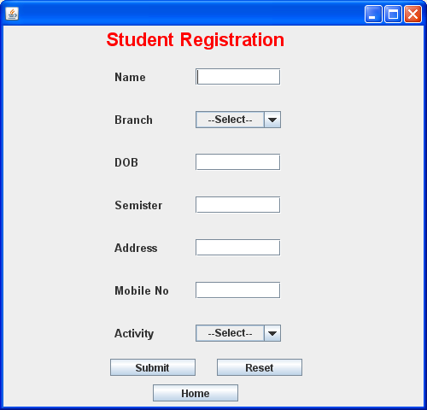

Send SMS Page

